Reagan Ferguson Logo:

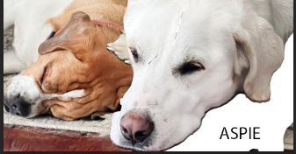

The first thing I did was select two of my dogs in a photo and made them the center id the object. I then added a partial background. I then merged their faces close together and cut off the white dog’s face a bit. After that I added a little small text in the right corner of my screen. After that I made the image smaller and made it where the image would look good tiny on my screen.